Employee Name or Team:
Job Title:
Service:
Assessing Manager’s Name:
Assessing Manager’s Job Title:
Date Assessment Completed:

Risk Definitions | Assessment
L | Low : minor injuries requiring first aid – for example, grazes or minor cuts
M | Medium: an injury requiring further medical assistance – for example cuts needing stiches or broken bones
H | High: major injuries, such as paralysis, or death
N/A | Not applicable to current job
Residual Risk | Residual risk is the level of risk that remains after suitable control measures are introduced
Assess the risk of each activity between Low, Medium or High. Following introduction of risk control measures reassess for residual risk.

Activity | Person  at risk | Significant Hazards | Risk  L M H |  |  | Risk Control Measures | Residual Risk  L M H |  |  | N/A
Any other comments

Sign and file for reference
Employee’s Signature: |  | Date:
Line Manager’s Signature: |  | Date:

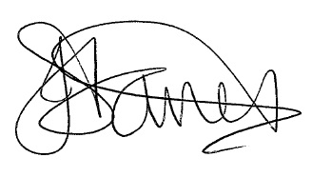
Date for revision: Annually or if any significant changes occur - Ensure review date recorded December 2018

