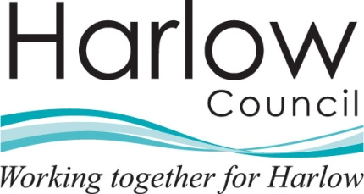 |  | Department name
The person(s) name |  | Harlow Council
Address Line 1 |  | Civic Centre
Address Line 2 |  | The Water Gardens
Address Line 3 |  | Harlow
Address Line 4 |  | Essex CM20 1WG
Address Line 5 |  | www.harlow.gov.uk
 |  | Our Ref:
 |  | Your Ref:
 |  | Date:

Re: Request for Information - Reference Number ******- Please quote this reference number if contacting the Council in relation to this matter.

Dear

Thank you for your request for information which was received on the [insert date]. We are dealing with your request under the Environmental Information Regulations 2004.

Request

[Insert request details]

Response
As required by the legislation, we aim to answer your request within 20 working days from the date we received it. If for any reason we are unable to meet this deadline we will keep you fully information of the reasons for this.
For your information, the Regulations define a number of exceptions which may prevent the release of information you have requested. If any of the exceptions apply then there will be an assessment of the public interest. You will be informed in writing if the Council decides not to release the information you will also be advised of your rights of appeal.
If the information you request contains reference to a third party then they may be consulted prior to a decision being taken on whether or not to release the information to you. You will be informed if this is the case.
There may be a fee payable for this information. This will be considered and you will be informed if this is the case. In the event the fee must be paid before the information is processed and released. The 20 working day time limit for responses is suspended until receipt of the payment.
If you have any queries concerning your request please ring Contact Harlow on (01279) 446655 or contact us at the above address.
Yours sincerely,

Officer Name
Officer Title
Tel: 01279 446 Fax: 01279 446
e-mail: your e-mail address @harlow.gov.uk

