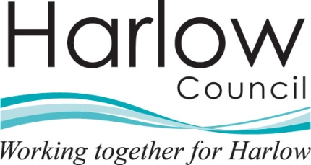 |  | Department name
The person(s) name |  | Harlow Council
Address Line 1 |  | Civic Centre
Address Line 2 |  | The Water Gardens
Address Line 3 |  | Harlow
Address Line 4 |  | Essex CM20 1WG
Address Line 5 |  | www.harlow.gov.uk
 |  | Our Ref:
 |  | Your Ref:
 |  | Date:

Re: Request for Information - Reference Number ******- Please quote this reference number if contacting the Council in relation to this matter.

Dear

Thank you for your request for information which we received on the [insert date]. Your request has been considered under the Environmental Information Regulations 2004.

Request

[insert requested information]

Response

After giving careful consideration to your request I am able to respond in part by providing you with some of the information you are seeking. I have enclosed a (paper / electronic, etc) copy of the information I am able to supply in respect of this aspect of your request.

or

As you have asked to view the records in which the information is contained, please telephone me on [number] to make the necessary arrangements.

Harlow Council is not able to give you the rest of the information because it is exempt from disclosure. I have set out the reasons for this decision below.

Exception Description | Reason / Explanation

Most of the information that we provide in response to the Freedom of Information Act 2000 / Environmental Information Regulations 2004 requests will be subject to copyright protection. In most cases the copyright will be owned by Harlow Council. The copyright in other information may be owned by another person or organisation, as indicated by the information itself.

You are free to use any information supplied for non-commercial research or private study purposes. The information may also be used for the purposes of news reporting. However, any other type of re-use, for example, publishing the information in analogue or digital form, including on the internet, or for commercial gain will require the permission of the copyright holder. In this case information disclosed by Harlow Council under the Freedom of Information Act 2000 / Environmental Information Regulations 2004 can be re-used in accordance with the Open Government Licence (OGL). Details of OGL can be found using the following link http://www.nationalarchives.gov.uk/doc/open-government-licence/ however copyright is maintained for logos, photographs and third party contributions to the information provided. For information about obtaining permission from a third party, see the Intellectual Property Office’s website at www.ipo.gov.uk

If you are dissatisfied with the response you have received and wish to request a review of our decision or make a complaint about how your request has been handled you should write to Contact Harlow at the above address or complete the on-line complaint form that can be found at www.harlow.gov.uk. Your request for an internal review should be submitted to us within 40 working days of receipt by you of this response. Any such request received after this time will only be considered at the discretion of Harlow Council.

If having exhausted the review process you are not content that your request or review has been dealt with correctly, you have a further right of appeal to the Information Commissioner for a decision by writing to the Information Commissioner’s Office, Wycliffe House, Water Lane, Wilmslow, Cheshire, SK9 5AF.

Yours sincerely,

Officer Name
Officer Title
Tel: 01279 446 Fax: 01279 446
e-mail: your e-mail address @harlow.gov.uk

