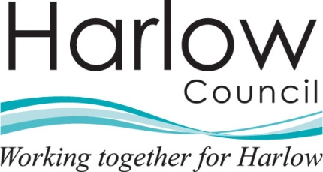 |  | Department name
The person(s) name |  | Harlow Council
Address Line 1 |  | Civic Centre
Address Line 2 |  | The Water Gardens
Address Line 3 |  | Harlow
Address Line 4 |  | Essex CM20 1WG
Address Line 5 |  | www.harlow.gov.uk
 |  | Our Ref:
 |  | Your Ref:
 |  | Date:

Re: Request for Information - Reference Number ******- Please quote this reference number if contacting the Council in relation to this matter.

Dear

Thank you for your request for information which was received on the [insert date]. We are dealing with your request under the Environmental Information Regulations 2004.

Request

[insert requested information]

Response

Unfortunately, in this case the amount of information you have requested is very substantial. Gathering it together would therefore be likely to involve a significant cost and diversion of resources from the Council’s other work. This could mean that we might have to charge you for the work involved or even have to refuse the request under the exceptions in the Environmental Information Regulations 2004 covering requests that are manifestly unreasonable or formulated in too general a manner.

The best way that we can help you is therefore to ask you to consider whether you could narrow down your request to focus on the precise information that you are seeking. You could, for example:

- be more specific about the time period covered by your request for correspondence;
- explain a bit more about the kind of scientific information you are looking for;
- browse through the material that has already been made publicly available on the Council’s website www.harlowgov.uk and see if this would help you to identify more precise questions that we might be able to answer at less cost.

If you are unable or unwilling to narrow down your request we will, of course, consider it in accordance with our obligations under the Environmental Information Regulations 2004. However we wanted to give you an opportunity to reconsider your request and describe more precisely the information you wish to have.

Let me know how you wish to proceed. In the meantime your request has been put on hold. If I do not hear from you within 30 days of the date of this letter I will assume that you no longer want this information and I will therefore take no further action.

Contact me again if you require any further assistance on this matter and I will do my best to provide relevant help and advice.

If you are dissatisfied with the response you have received and wish to request a review of our decision or make a complaint about how your request has been handled you should write to Contact Harlow at the above address or complete the on-line complaint form that can be found at www.harlow.gov.uk. Your request for an internal review should be submitted to us within 40 working days of receipt by you of this response. Any such request received after this time will only be considered at the discretion of Harlow Council.

If having exhausted the review process you are not content that your request or review has been dealt with correctly, you have a further right of appeal to the Information Commissioner for a decision by writing to the Information Commissioner’s Office, Wycliffe House, Water Lane, Wilmslow, Cheshire, SK9 5AF.

Yours sincerely,

Officer Name
Officer Title
Tel: 01279 446 Fax: 01279 446
e-mail: your e-mail address @harlow.gov.uk

