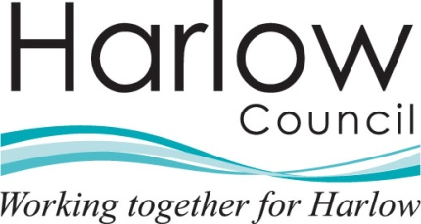 |  | Department name
The person(s) name |  | Harlow Council
Address Line 1 |  | Civic Centre
Address Line 2 |  | The Water Gardens
Address Line 3 |  | Harlow
Address Line 4 |  | Essex CM20 1WG
Address Line 5 |  | www.harlow.gov.uk
 |  | Our Ref:
 |  | Your Ref:
 |  | Date:

Re: Request for Information - Reference Number ******- Please quote this reference number if contacting the Council in relation to this matter.

Dear

Thank you for your request for information, which was received on the [insert date].

Request

[insert requested information]

Response

Your request is being considered and you will receive the information requested within the statutory timescale of 20 working days as defined by the Freedom of Information Act 2000, subject to information not being exempt or containing a reference to a third party.

The Freedom of Information Act 2000 provides public access to information held by public authorities. The Act covers any recorded information that is held by a public authority in England, Wales and Northern Ireland, and by UK-wide public authorities based in Scotland.

Recorded information includes printed documents, drafts, computer files, letters, emails, notes, photographs, and sound or video recordings.¹

For your information, the Act defines a number of exemptions which may prevent the release of information you have requested. There will be an assessment and if any of the exemption categories apply then the information will not be released. You will be informed if this is the case, including your rights of appeal.

If the information you request contains reference to a third party then they may be consulted prior to a decision being taken on whether or not to release the information to you. You will be informed if this is the case.

There may be a fee payable for this information. This will be considered and you will be informed if this is the case. In the event the fee must be paid before the information is processed and released. The 20 working day time limit for responses is suspended until receipt of the payment.

The Act does not give people access to their own personal data (information about themselves) such as their health records or credit reference file. If a member of the public wants to see information that a public authority holds about them, they should make a subject access request under the Data Protection Act 1998.1

If you have any queries concerning your request please ring Contact Harlow on (01279) 446655 or contact us at the above address.

Yours sincerely,

Officer Name
Officer Title
Tel: 01279 446 Fax: 01279 446
e-mail: your e-mail address @harlow.gov.uk

Information Commissioner’s Office, The Guide to Freedom of Information Version 4.9.5 October 2014, licensed under the Open Government Licence

