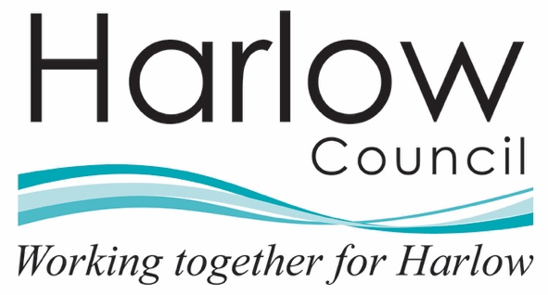

Harlow Health and Wellbeing Partnership

Public Health Community Grant Fund 2025-26

Project Monitoring & Evaluation Form

Project Monitoring and Evaluation Survey
Q1. Selecting "I agree" below indicates that:
- you voluntarily agree to participate
- you are at least 16 years of age
- you understand that your data is not able to be withdrawn once submitted

Selecting this box (x) confirms you agree with the above:
☐

Q2. What is your name?
Please include the name of the person completing this survey

Q3. What is your email address?
Please include your email address

Q4. What is the name of your funded organisation?
Please include the name of your organisation

Q5. What is the name of this funded project?
Please include the name of the project. If you have more than one funded project, you will need to complete a new survey response for each.

Q6. Please give us a brief description of this project and how it has supported the health and wellbeing priority (or priorities) that you were targeting.
Please give a short description of the project, this may include the types of activities you are doing, where it is based and the target population.

Q7. When is/was the approximate start date for delivery of your funded project?
What was the start date of the project. This can be approximate (to the month) if you do not know the exact date.

Q8. When is/was the approximate end date for delivery of your funded project?
Please include the estimated month your project is due to end.

Q9. To date, how many sessions has your project had?
Please include the number of sessions your project has had so far. We will ask you the total number once your project has been completed. If your project is an event, campaign or activity without ‘sessions’, please add further information about engagement in Q12-13.

Q10. Please record the TOTAL number of attendances TO DATE from adults (aged 19 and over) in your funded project
Please include the total number of attendances from adults your project has had so far e.g. 1 adult attending 4 sessions = 4. We will ask you the total number of attendances once your project has been completed.

Q11. Please record the TOTAL number of attendances TO DATE from children and young people (aged 0-18) in your funded project
Please include the total number of attendances from young people your project has had so far e.g. 1 young person attending 4 sessions = 4. We will ask you the total number of attendances once your project has been completed.

Q12. Please provide us with some details on the audience you reached through your project.
Please include whether your project had a target audience, what groups your project reached and any data in this area, e.g. breakdown on participants by gender, ethnicity, disability, or other relevant factors.

Q13. Please tell us about other figures or statistics about your project e.g. social media engagement, any outcome data you may have collected.
Please include any other statistics that your project has recorded. This may be information such as social media and website engagement (no of hits/downloads etc.), data from any surveying you have done with participants (satisfaction/outcomes), number of items distributed (leaflets/health packs).

Q14. Please provide a total project/initiative spend breakdown.
Please include total project spend breakdown, using the relevant categories in the box below. You must include overall cost of the project.

Equipment/materials:
Staff salary:
Venue costs:
Insurance:
Marketing:
Evaluation:
Other costs (please state):
Overall Cost:

Now we would like you to reflect on your funded project from planning phases through delivery and until completion, and answer the following questions:
Q15. Has anything changed because of this project?
Please include information here such as: has your project received additional funding from other sources? Do you plan to continue? How has this project informed other work.

Q16. Please describe the aspects of your funded project that have worked well. Please include the impact on individuals and the local community.
Please include information on things that have worked well. What are your key highlights?

Q17. Please describe any challenges that your funded project has experienced and what you have learnt from tackling these.
Please include information on things that have haven’t worked as well. Have you had any key challenges? how do you plan/how did you overcome these? Is there any support that the Health and Wellbeing Board can provide to help?

Q18. Has your organisation collaborated with any other organisation or individuals to support this project. If so who, and what was their contributions? Please advise if they received any of the Health and Wellbeing Funding.

Q19. Please describe any adaptations or improvements that you/your organisation have made to your funded project from your initial proposal and why?
Please let us know if you have made any changes to your project since approval and why these were necessary.

Q20. Please upload any quotes, case studies from participants/volunteers/staff members (include their name and age where possible). Also upload any photos or videos that were taken during delivery of your funded project.
Please share any quotes, case studies, or photos from your project. Please give as much detail as you can- these help us to bring the project alive. Please ensure everything you upload has appropriate consent.

Q21. I confirm participant(s) have given verbal consent to use any quotes, case studies, and photos (if applicable)
Please let us know if you got consent from the individuals whose stories you are sharing. We may want to share these on our social media pages or in evaluation reports. Please indicate whether we can use the stories for these purposes.

Selecting this box (x) confirms participant(s) have given verbal consent to use any quotes, case studies, and photos:
☐

Q22. Is there any other evaluation information that you are collating and would like to share with us?
Please let us know if there is anything else you would like to share with us.

Q23. Any other comments
Please let us know if there is anything else you would like to share with us.

Q24. I confirm that all information in this evaluation report is correct to the best of my knowledge and the funds received from Harlow Council’s Public Health Community Grant Fund in the 2025-26 financial year have been spent on the project that was approved by the board.
Selecting this box (x) confirms the above statement is correct:
☐

Name:
Signature:
Date:

Thank you for taking the time to complete this survey. We use this information to understand the impact of the Public Health Community Grant Funding across Harlow. If you have any questions, please get in touch with health.wellbeing@harlow.gov.uk.

