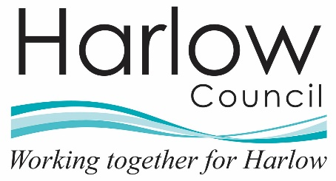

Volunteer agreement
This Volunteer Agreement describes the arrangement between Harlow Council and you.
We wish to assure you of our appreciation of your volunteering with us and will do the best we can to make your volunteer experience with us enjoyable and rewarding.

Part 1: The Organisation
Your role as a volunteer is [state nature and components of the volunteering role] and starts on [date]. This volunteering role is designed to [state how the volunteering role benefits the organisation].
You can expect Harlow Council:

1. Induction and training
- To provide an induction on the work of Harlow Council, (insert service area) its staff, your volunteering role and the induction and/or training you need to meet the responsibilities of this role.

2. Supervision, support and flexibility
- To explain the standards, we expect for our services and to encourage and support you to achieve and maintain them.
- To provide a named person who will meet with you regularly to discuss your volunteering and any successes and problems.
- To do our best to help you develop you’re volunteering role with us.

3. Expenses
- Any expenses must be agreed in advance. Please keep all your receipts to give to us when we reimburse your expenses.

4. Health and safety
- To provide adequate training and feedback in support of our health and safety policy.

5. Insurance
- To provide adequate insurance cover for volunteers whilst carrying out their volunteering roles which have been approved and authorised by us

6. Equal opportunities
- To ensure that all volunteers are dealt with in accordance with our equal opportunities policy.

7. Problems
- To try to resolve fairly any problems, complaints and difficulties you may have while you volunteer with us.
- In the event of an unresolved problem, to offer an opportunity to discuss the issues in accordance with the procedures set out within organisational policies and procedures.

Part 2: The Volunteer
There is a requirement to:
- Help Harlow Council fulfil its [describe role/function/services which the volunteer will be helping with].
- Perform your volunteering role to the best of your ability.
- Follow the organisation’s procedures and standards, including health and safety and equal opportunities, in relation to its staff, volunteers and clients.
- Maintain the confidential information of the organisation and of its clients.
- Comply with Data Protection legislation and GDPR.
- Comply with all policies relating to IT and Network systems where access is provided.
- Meet the time commitments and standards which have been mutually agreed to and to give reasonable notice so other arrangements can be made when this is not possible.
- If applicable, to provide referees as agreed who may be contacted.
- If applicable, to undertake a Disclosure and Barring Service (DBS) check where necessary.
This agreement is binding in honour only, is not intended to be a legally binding contract and is not subject to the national minimum wage between us and may be cancelled at any time at the discretion of either party. Neither of us intend any employment relationship to be created either now or at any time in the future.
Harlow Council appreciates all work undertaken by volunteers and would like to thank you for your commitment to its services.
Signature
Date

